INTRODUCTION TO URBAN STUDIES
Course Syllabus - Spring 2026, Main Campus
Instructor: Professor Nausheen H. Anwar

Monday/Wednesday
Office Hours: 1-2 pm Monday

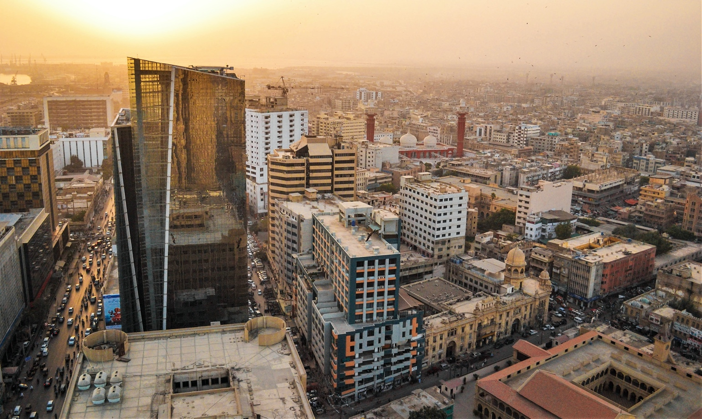

COURSE DESCRIPTION
This course enquires into the evolution of cities historically as well as contemporary processes of urbanization in the Global North and South. It introduces students to key explanatory frameworks for understanding the contemporary economic and social function of cities and the frameworks of analysis used in urban studies. The course will examine urbanization processes in the past and in contemporary contexts: what is a city? How do cities develop? What functions do they serve? Why do people live in cities? How does this change from one time to another, from one context to another? What are some examples of city formation both past and present, linking up the North and South? What are the impacts of climate change on cities? Urban Studies is an interdisciplinary field and presents models of how scholars approach cities from a variety of disciplinary viewpoints, including architecture, planning, sociology, history, anthropology, political science, and geography. Students will learn the works of leading scholars in the field over the last hundred years. Learning will be based not only on the readings but also on students’ own observations and research in the course’s written assignments and class room discussions.
COURSE GOALS
- Develop an understanding of why cities form and their functions;
- Develop an understanding of the culture, thoughts, institutions, policies, and processes shaping urban areas;
- Understand the differences between cities and urbanization processes;
- Develop distinct understandings brought to urban studies by different disciplinary approaches;
- Develop an understanding of key ideas, authors, and texts in the history of urban planning from the 19th century to the present;
- Improve the ability to express thoughts cogently and persuasively in writing and to organize evidence culled from research to support arguments;
- Improve research skills and the ability to articulate thoughts clearly and persuasively

ALL READINGS UPLOADED IN LMS

Foundational Reference Material: Encyclopedia of Urban Studies (2010) by Ray Hutchison (ed) – Available in IBA Library. Kindly consult this encyclopedia as it will help you to understand key terminology used throughout this course.

ASSESSMENT
- Critical Reading Responses: 20%
- Class Participation: 20%
- Mid-Term Exam: 10%
- Quizzes: 25%
- Class Attendance 5%
- Group Project (Policy Paper on Affordable Housing). 20% due May16th. Working in pairs of 2, students will write a Policy Paper of maximum 4000 words on how to improve the housing situation in Pakistan’s cities for the urban poor. This project focuses on secondary data collection. Students are expected to read with care, Government of Pakistan published papers, academic/scholarly papers, articles by urban planners, newspaper/media reports; knowledge produced by activists, university research centers, e.g., Karachi Urban Lab (KUL), and by NGOs, e.g., the Urban Resource Centre (URC), to assess (1) What are the reasons for lack of government provision of affordable housing for the urban poor in Pakistan? (2) How is this impacting the urban poor’s housing concerns? (3) Were government initiatives introduced in the past and if so, why did they fail? (4) Is the housing crisis a matter of supply only or is it also a matter of urban planning and design? In addition to keeping in mind these questions, students will write a policy recommendation for resolving the housing crisis in Pakistan. Key issue: Is the private sector a viable player in resolving the housing crisis for the urban poor? To examine this question, students will study the government’s current plan for affordable housing. Students will follow certain guidelines to produce a well-researched and well-argued policy paper. All teams will make presentations in the last week of semester. For guidelines on writing a good policy paper, see:
https://writingcenter.unc.edu/tips-and-tools/policy-briefs/

Important Note: Missing more than five (5) classes will greatly impact your ability to stay abreast of the readings and discussions, and your final grade will be seriously compromised or I might even ask you to drop the course. This is a READING INTENSIVE course that requires consistent engagement. I will not make any accommodations if your grade slides due to delayed assignments, and generally poor-quality output. It is YOUR responsibility to keep track of assignments, discussions, performance, output. Read this syllabus carefully and consult it regularly and thoroughly.

Weekly Plan of Lectures (uploaded on LMS)
Week | Class Description and Readings
 | Introduction – Jan 28nd
- Distribution of course material
- What do students expect to get out of this course?
- Discussion of Syllabus
- Describe approaches used in Urban Studies

A bit of Theory – Feb 2nd
This week’s reading aims at clarifying the theoretical perspective of the course, avoiding linear narratives, and remaining open to parallel explanations. Michel Foucault is a key philosopher for questioning the dominance of universal subjects and metanarratives in modernist theory.

- Lydia A. Fillingham (1993) “The Order of Things”, from Foucault for Beginners, pp. 78-110.
- Gary Gutting (1989) The Order of Things I: From Resemblance to Representation (pp. 139-156; pp. 173-177); The Order of Things II: The Rise and Fall of Man (pp.181-184; pp. 198-209), from Michel Foucault’s Archaeology of Scientific Reason. Cambridge, UK: Cambridge University Press. (PDF available in LMS)

The Rise of the Industrial City – Feb 4th
Early 19th century London is our entry point to the Modern City. The industrial revolution engendered drastic changes in England’s social organization, displacing entire social groups and creating new social classes. It also triggered sweeping spatial changes. Massive out-migrations from the countryside changed the relationship city-countryside and changed the spatial organization of the city. It also ignited a rich, intellectual debate on planning, design and city futures.

- The Great Towns, Frederic Engels
- Great Expectations 1815-1848, from The Origins of Modern Town Planning. London: Routledge & Kegan Paul, pp. 20-38.

Reimagining the City: Utopia, Reformism, and fear - Feb 9th
The industrial revolution brought to light two notions that influence understanding of cities and the way in which we change them. Utopia is the dream of the good city from which we endlessly design new urbanities. Fear is the dark side of utopia, equally influential in the making of cities both in historical and contemporary contexts.

- The City of Dreadful Night, Peter Hall
- Thresholds of Fear: Embracing the Urban Shadow, Nan Ellin
- City of Walls, Teresa Caldiera, pp. 19-34;
- Nineteenth-Century Utopias, Leonardo Benevolo (1967) pp. 39-75.
- The Contemporary City, Le Corbusier
- Garden Cities of Tomorrow, Ebenezer Howard
What is a city? - the search for order - Feb 11th
The Chicago School of Urban Sociology was the first comprehensive attempt to understand the industrial city. Although this school is no longer the dominant urban account, it still remains the term of comparison of most urban studies and its organic metaphor still echoes in much of current talks of the city. We also look at the work of a pioneering urban scholar, Jane Jacobs, whose ideas about what constitutes a good city will be explored in the first assignment for this course.

- What is a city? Lewis Mumford
- The Growth of the City: an Introduction to a Research Project, Ernest W. Burgess
- Urbanism as a way of life, Louis Wirth
- The Metropolis and Mental Life, George Simmel
- The Sociological Significance of the Ghetto, Louis Wirth (1956, orig. 1928)
- The Uses of Sidewalks: Safety, Jane Jacobs
Browse website: http://www.pps.org/reference/jjacobs-2/

Exclusions, Expulsions, Containment– suburbanization, ghettos – Feb 16th
Film: La Haine
This week focuses on the issue of social and spatial discrimination. While the Chicago School saw social enclaves, as natural mechanisms of preservation for ‘weak’ social groups, more recent studies identify economic and spatial marginalization as key actors in producing and maintaining enclaves and in forming social identity.

- Race, Ethnicity, and Real Estate Appraisal: "The Home Owners Loan Corporation and the Federal Housing Administration, Kenneth T. Jackson
- Ghettoes and Anti-Ghettoes: an Anatomy of the New Urban Poverty, Loïc Wacquant
- Urban Desolation and Symbolic Denigration in the Hyperghetto, Loïc Wacquant
- Three Pernicious Premises in the Study of the American Ghetto, Loic Wacquant

Race & Housing – 25 minute video: https://vimeo.com/133506632

Colonialism & the North-South Interface - Feb 18th - 23rd

Colonialism is a particular form of imperialism. Modern colonialism refers to the historical period between the 18th and the first half of the 20th century and to the metropolitan country’s direct political control of dependent territories. But one of the most visible expressions of colonialism, which is often neglected in the broader discourse of imperialism, is the hegemonic role of the dominant power in the production of social identities and of spatial differentiation between the colonizer and the colonized.

- Tradition in the service of Modernity: Architecture and Urbanism in French Colonial Policy, Gwendolyn Wright
- Le Corbusier and Algiers: the Plan Obus and Colonial Urbanism, Michele Lamprakos N. Al Sayyad (ed.) Forms of Dominance: on the Architecture and
Urbanism of the Colonial Enterprise, pp. 183-210.
- Colonial modernism and the flawed paradigm of urban renewal, Hazareesingh
- Colonialism and Collaboration: Chinese Subjects and the Making of British Hong Kong and A Place of Their Own: Clubs and associations, John M. Carroll
- City of Monuments, Chpt 6 in Peter Hall (pdf)
- The Colonial Bungalow, Anthony D King, pdf.
- Colonialism and Urban Development, Anthony D King (pdf)

Browse Website:
http://architecturalmoleskine.blogspot.com/2012/11/chandigarh-and-le-corbusier-i.html
Fordism & variations on urban form - Feb 25th

Post-World War Two, both the economy and cities underwent a series of changes. Focusing on the USA, this session covers the broad socioeconomic changes that Fordism triggered. Following the ‘Regulation School’, it focuses on mass production and consumption, and on the establishment of regulatory mechanisms between the two. Session also covers two urban elements (the suburb, the mall) and their relevance to Fordism. These forms link mass production and mass consumption.

- Condition of Post modernity, Harvey (pdf) Chapter on Fordism 125-140.
- ‘Long Waves’ in the History of Capitalism, from Late Capitalism,(pdf) Ernest Mandel Late Capitalism, London, Verso, pp. 108-146.
- The Mall, Wrigley & Lowe (chapter 12)
- Crabgrass Frontier, Kenneth Jackson (Chapters 1 and 11)

Kindly check David Harvey’s lecture on wants, needs and desires: http://www.cccb.org/en/multimedia/videos/culture-and-cities-the-challenge-of-tourism/225261

Decolonization & the City – March 2nd – 4th

From this week we begin with the social unrest that shook the accepted social order in cities as different as Paris, Los Angeles, or Algiers and opened the door for different conceptualizations of the urban. The movie The Battle of Algiers serves as introduction to crisis. Recalling the “two cities” of 19th century London, the movie highlights the boundaries between the colonizers and the colonized, their two ways of life, their two cities, and how difficult it is to cross from one to the other, without ‘mimicking’ the other.

FILM: Gillo Pontecorvo (1966) The Battle of Algiers (121 min.)

- Traditions of the Modern, Ananya Roy
- Islamabad and the Politics of Development in Pakistan, Daechsel, Markus
- US Planning Expeditions in Postcolonial India: From Ideology to Innovation in Technical Assistance, Banerjee, Tridib Banerjee
 | Midterm Exam – 9th – 14th March
Modern States & Political Space – March 16th

This week we read sections of a book written by the architect/visual scholar Eyal Weizmann on how political space is created via architecture and urban planning, as tools of a modern state’s policy of dispossession and occupation.

- Hollow Land, Eyal Weizman (Introduction, Chapters 1, 2, 4, 7)

Kindly check out: http://izk.tugraz.at/semesters/summer-semester-2016/eyal-weizman-violence-at-the-threshold-of-detectability/

What is Forensic Architecture?

Globalization – finance, urban renewal, politics in north and south – March 23rd
This week we look at urbanization through the lens of globalization. We examine how increased financial globalization has transformed urbanization processes in the past two decades but also how new ideas and practices of citizenship, new urban governance structures, and urban and global social movements are changing our cities in the global north and south.

- Contested Cities: Social Processes and Spatial Form, David Harvey
- Producing Cosmopolitan Karachi, Anwar & Viqar
- The Dream of Delhi as a Global City, Veronique Dupont
- African Fantasies, Victoria Watson
- Scheherazade Syndrome, Clara Irazabel

Browse website:
http://bradmax25.blogspot.sg/2014/09/contested-cities-social-process-and.html

New spatial forms – slums, gated communities , enclaves - March 25th

Film: Metro Manila
In this week’s sessions, we unpack the categories ‘slum’ and ‘gated communities’ and revisit the ‘enclave’ by approaching these as political, cultural and spatial processes in the context of local-global dynamics. A reminder: the category ‘slum’ was first introduced in the context of changing socio-spatial forms of industrialization in England in the 19th Century. The exploration of the category ‘slum’ forms a key part of your second assignment for this course.

- The Durable Slum, (2016) Weinstein, Liza – entire book
- Return of the Slum, Gilbert, Alan
- This is a lot like the Bronx, isn’t it?’ Lived experiences of marginality in an Argentine slum, Auyera, Javier (pdf)
- Paragons of Lifestyle: gated communities, Mark-Anthony Falzon
- Enclaves, insecurity and violence in Karachi, (2014) Kaker, Sobia

https://smcsfootnotes2015.wordpress.com/2015/08/17/when-home-is-a-dump/

https://www.wionews.com/south-asia/the-politics-of-planning-indian-cities-contradictions-inequalities-and-emerging-trends-5866

https://theconversation.com/the-mall-isnt-dead-its-just-changing-72237?utm_source=twitter&utm_medium=twitterbutton

Displacements, Evictions – the Millennial Southern City – March 30th – April 1st – April 6th

In this week’s session, we look at the political and structural dynamics that underwrite processes of eviction and displacement in cities in the Global South. These processes range from outright evictions of residents in informal settlements to ‘land grabbing’ in rural areas. We look at the mechanisms and drivers of evictions including land commodification, property speculation, urbanization, beautification, and infrastructural development/growth.

- This is no longer the city I once knew (2009) Bhan, Gautam
- Receding Rurality, Booming Periphery: Value Struggles in Karachi’s Agrarian Urban Frontier (2018) Anwar, Nausheen H.
- Nuisance Talk and the Propriety of Property: Middle Class Discourses of a Slum‐Free Delhi (2012) Ghertner, Asher
- Urbanization through dispossession: survival and stratification in China's new townships, (2015) Chuang, Julia
- When land becomes gold (2018) Gururani, Shubra
- IDMC, ‘Technical Paper: The Risk of Disaster-induced Displacement’ (2013) http://www.internal-displacement.org/idmc/website/resources.nsf/(httpPublications)/A6739FF3AF535330C1257C36005959BF?OpenDocument

Planning Urban Futures in 21st Century – April 8th – 13th

In our final session, we reconsider urban futures through the lens of Climate Justice and Extended Urbanization. How are climate justice and right to the city linked?

- Theses on Urbanization, Neil Brenner (2013) Public culture, (25)1
- Climate justice, urban futures and the gendering of cities in South Asia, Nausheen Anwar & Malini Sur (2020) pdf - pages 66 - 79
- Climate Justice & the Right to City (2018) Daniel Aldana Cohen https://penniur.upenn.edu/uploads/media/Cohen.pdf

 | April 15 – 29th – These sessions are devoted to work on Policy Paper
 | Final Exam – May 11th
 | May 16th – POLICY PAPER DUE

